**BANK LOAN APPLICATIONS ANALYSIS**

**KPI’s:**

1. **Total Loan Applications:**

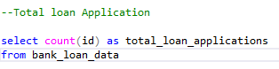

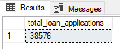

**MTD Loan Applications**



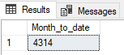

**MoM Loan Applications**



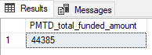

1. **Total Funded Amount:**

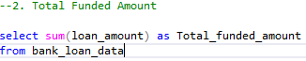

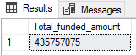

**MTD Funded Amount**



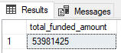

**PMTD Funded Amount**



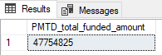

1. **Total Amount Received:**



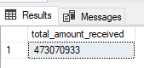

**MTD Total Amount Received:**



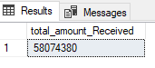

**PMTD Total Amount Received**



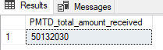

1. **Average Interest Rate**



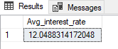

**PMTD Average Interest Rate**

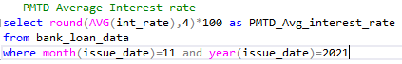



1. **Average Debt-to-Income Ration (DTI)**



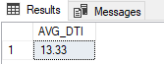

**MTD AVG DTI**



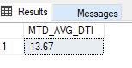

**PMTD AVG DTI**

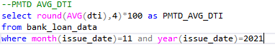

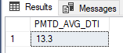

**Good Loan Vs Bad Loan KPI's**

1. **Good loan Application Percentage**

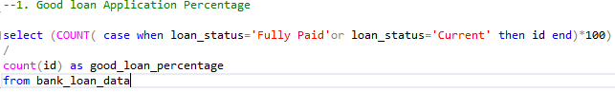

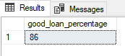

1. **Good Loan Applications**

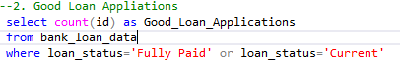

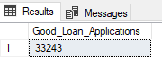

1. **Good Loan Funded Amount**

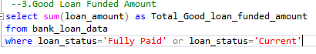

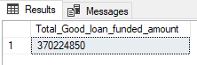

1. **Good Loan Total Received Amount**

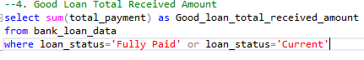

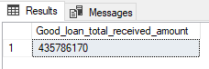

**Bad Loan KPI’s**

1. **Bad Loan Percentage**

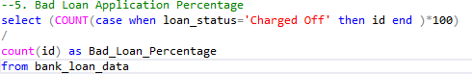

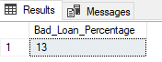

1. **Bad Loan Applications**

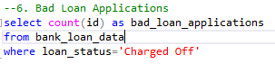

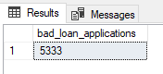

1. **Bad Loan Funded Amount**

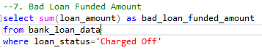

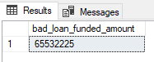

1. **Bad Loan Total Received Amount**



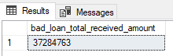

**Loan Status**

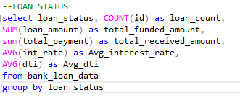

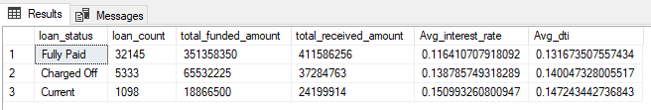

**LOAN STATUS MTD Total Amount Funded & Received**

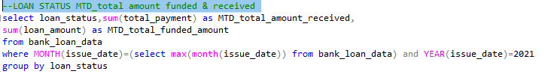

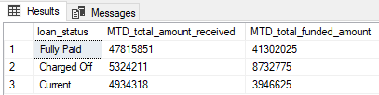

**Bank Loan Report Overview**

**DASHBOARD 2:CHARTS**

1. **Monthly Trends by Issue Date**

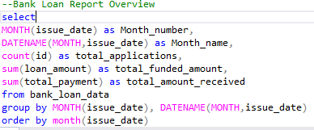

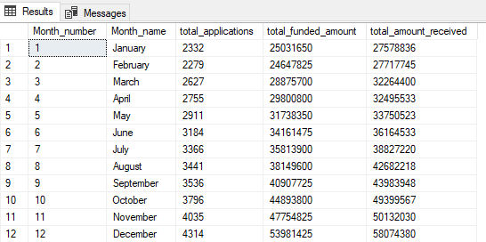

1. **Loan Term Analysis:**

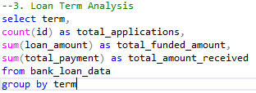

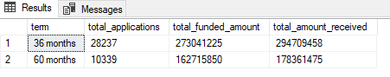

1. **Employees lengths Analysis:**

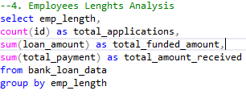

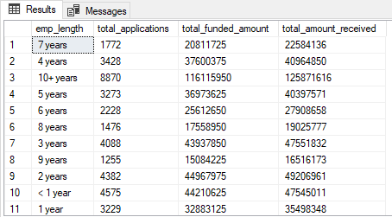

1. **Loan Purpose breakdown:**

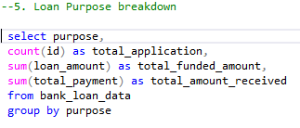

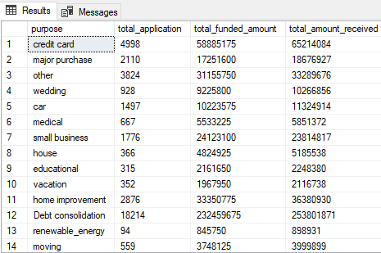

1. **Home Ownership Analysis:**

